Date: ,2022

The Japan Foundation Awards (2022)
Nomination Form
Please submit the completed nomination form to kikinsho@jpf.go.jp by email.
*Self-nominations, including nominations of an organization or head of an organization to which the nominator belongs, will not be considered as an eligible candidate.
Nominator
Name
Title/Organization
 | Tel： |  | Fax：
 | E-mail：
 | (Signature)
For the people in the EEA (European Economic Area) member countries |  | I agree with the Privacy Policy (https://www.jpf.go.jp/e/privacy/) of  the Japan Foundation (Please mark the box with an “×”)

Nominee
Individual/  Organization | Individual (Please mark the box with an “×”)
 | (Surname) | (Given name)
 | (Title/Position)
 | Organization (Please mark the box with an “×”)
 | (Name & Title of the Representative)
 | (Year of Birth / Establishment)
Address
 | Tel： | Fax：
 | E-mail：

Nominator’s Remarks
Nominee’s
Educational and
Professional
Background,
Achievements,
Awards received
Organization’s
History, Activities,
Achievements,
Awards received
The Japan Foundation Awards (2022) Nomination Form (Page 2 of 3)
The Japan Foundation Awards (2022) Nomination Form (Page 3 of 3)
The organization’s
Budget Scale and
Resources
(Please fill in if you’re nominating an organization)

Nominee’s Additional Information, URL
＊The personal information provided in the nomination form will be handled responsibly and used solely for the purpose of selecting the recipients of the Japan Foundation Awards 2022. As a part of the screening process, the name and title of a nominator as well as information about the candidate(s) will be provided to the selection committee.
Please submit the completed nomination form to kikinsho@jpf.go.jp by Email (If you can’t submit it by Email, please send it to us by Fax or post).
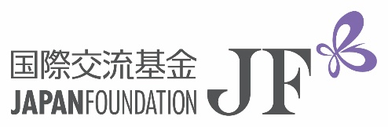 | The Japan Foundation  Address: The Japan Foundation Awards Secretariat c/o Communication Center, The Japan Foundation  YOTSUYA CRUCE, 1-6-4 Yotsuya, Shinjuku-ku, Tokyo 160-0004, Japan  E-mail: kikinsho@jpf.go.jp Tel: (+81) 3-5369-6075 Fax: (+81) 3-5369-6044  https://www.jpf.go.jp/e

